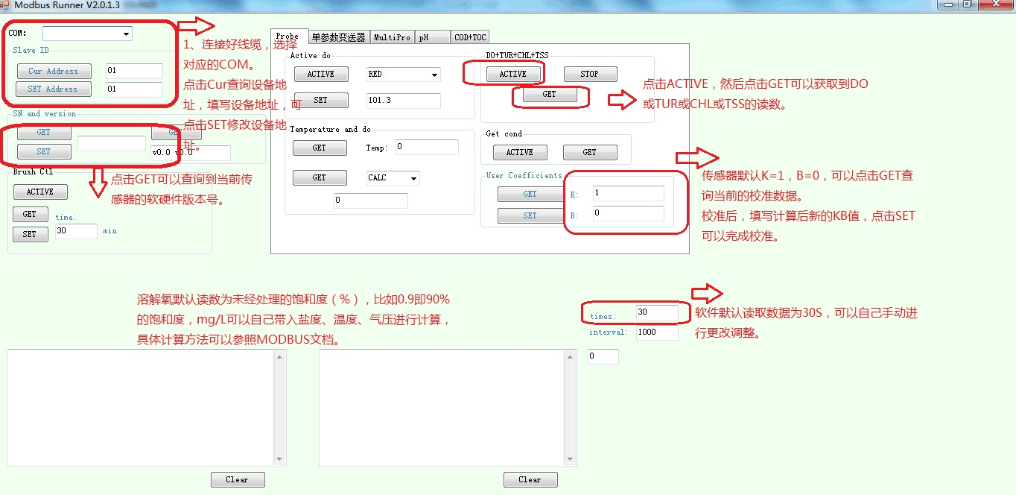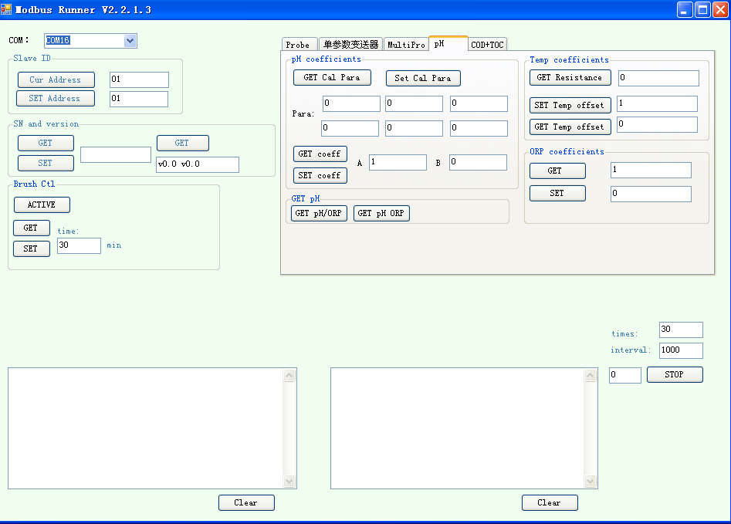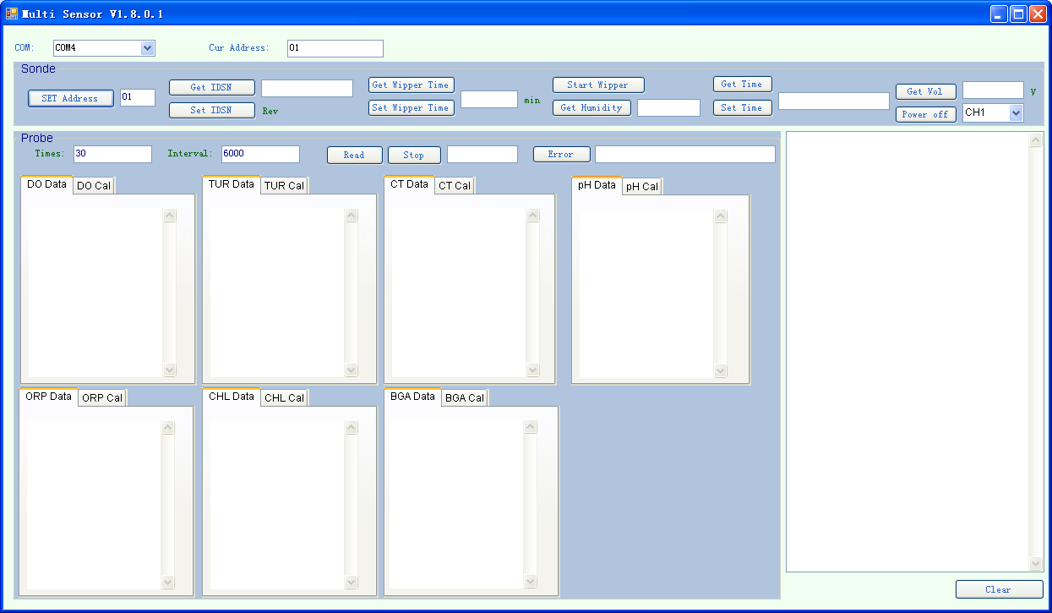

Click “GET pH/ORP” can get pH value

2 Click “GET” to get serial number

The data will continue coming every one second until the number of groups up to 30 by default. You can change times and interval as your demand.

1 Chose COM.

Click “Cur” to

get current

Modbus ID.

Click ”SET” to

Change ID.

Serial number

If the warning light is red , please click “Error” to get further information.

2 Click “Read” can get all five parameter values

The data will continue coming every six seconds until the number of groups up to 30 by default. You can change times and interval as your demand.

Change the wiper brush interval time for each rotation. The default time is 30 minutes.

Active brush.

1 Chose COM. The default current Modbus ID is 01.

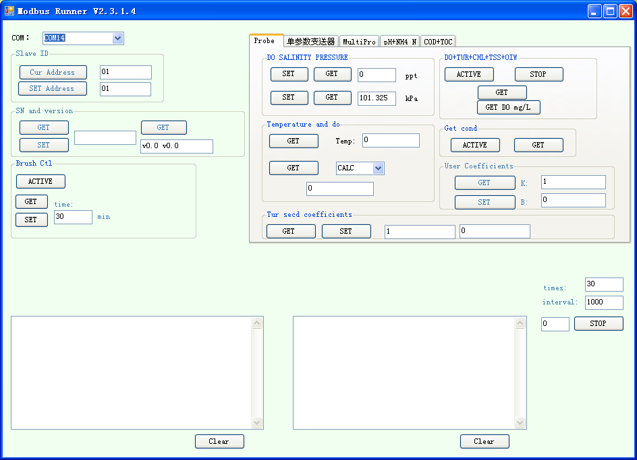

You can get current User coefficients and replace to the new you calculated.

3 Click “GET” can get temperature and Sensor value

2 Click “GET” to get serial number of CHL

1 Chose COM.

Click “Cur” to

get current

Modbus ID.

Click ”SET” to

Change ID.